PERSONAL ROADMAP PLANNER (SKILLS)
@CREATIVITY THINK (9483175986/7019689991)

ABSTRACT:
Personal Roadmap Planner (Skills) is a dynamic web-based application designed to help learners plan, track, and visualize their skill development journey. Users can select skills such as Django, React, DSA, or any custom skill, set milestones and tasks, and monitor their growth through a progress dashboard. The platform includes timeline views, completion percentages, pending task alerts, and overdue goal indicators, making it ideal for students, career switchers, and self-learners.
Administrators can manage global skills, publish templates, and optionally monitor platform usage analytics. Built using Django REST Framework and React, this system ensures smooth performance, user-friendly navigation, and real-time progress tracking..

INTRODUCTION OF THE PROJECT:
Skill development requires structured planning, measurable goals, and continuous tracking. Many learners struggle to stay consistent due to lack of planning tools, scattered notes, and difficulty visualizing progress.
Personal Roadmap Planner (Skills) solves this challenge by offering a centralized platform where users can create individualized skill roadmaps, break them into milestones and tasks, update progress, and view timelines and dashboards.
The system also assists admins in creating global templates to help new users get started instantly. With interactive UI and graphical progress visualization, the platform simplifies long-term learning management..

PROJECT OBJECTIVES:

• Provide user-specific skill selection and roadmap creation
• Allow creation of milestones and tasks for each skill
• Track task completion with checklist-style updates
• Offer timeline and progress dashboard views
• Display completion percentages and pending/overdue tasks
• Enable admins to create and manage global skill templates
• Provide optional admin analytics on platform usage
• Ensure responsive and interactive UI using React

PROBLEM OF THE STATEMENT:
Learners often lack a structured and organized system for tracking their skill development. Notes are scattered, reminders are manual, and progress is not easily visualized. Traditional planning tools do not offer skill-based milestones, task breakdown, or timeline views.
Personal Roadmap Planner provides a unified platform to solve these issues by offering skill-wise tracking, structured milestones, visual dashboards, and admin-driven templates..

MOTIVATION OF THE PROJECT:
• To support students and career switchers in organized learning
• To provide a visual timeline and dashboard for progress motivation
• To reduce dependency on manual note-taking or spreadsheets
• To help users maintain consistency with clear milestones and goals
• To allow administrators to standardize skill templates for learners
• To improve long-term learning outcomes through structured planning

BLOCK DAIGRAM OF PROJECT:

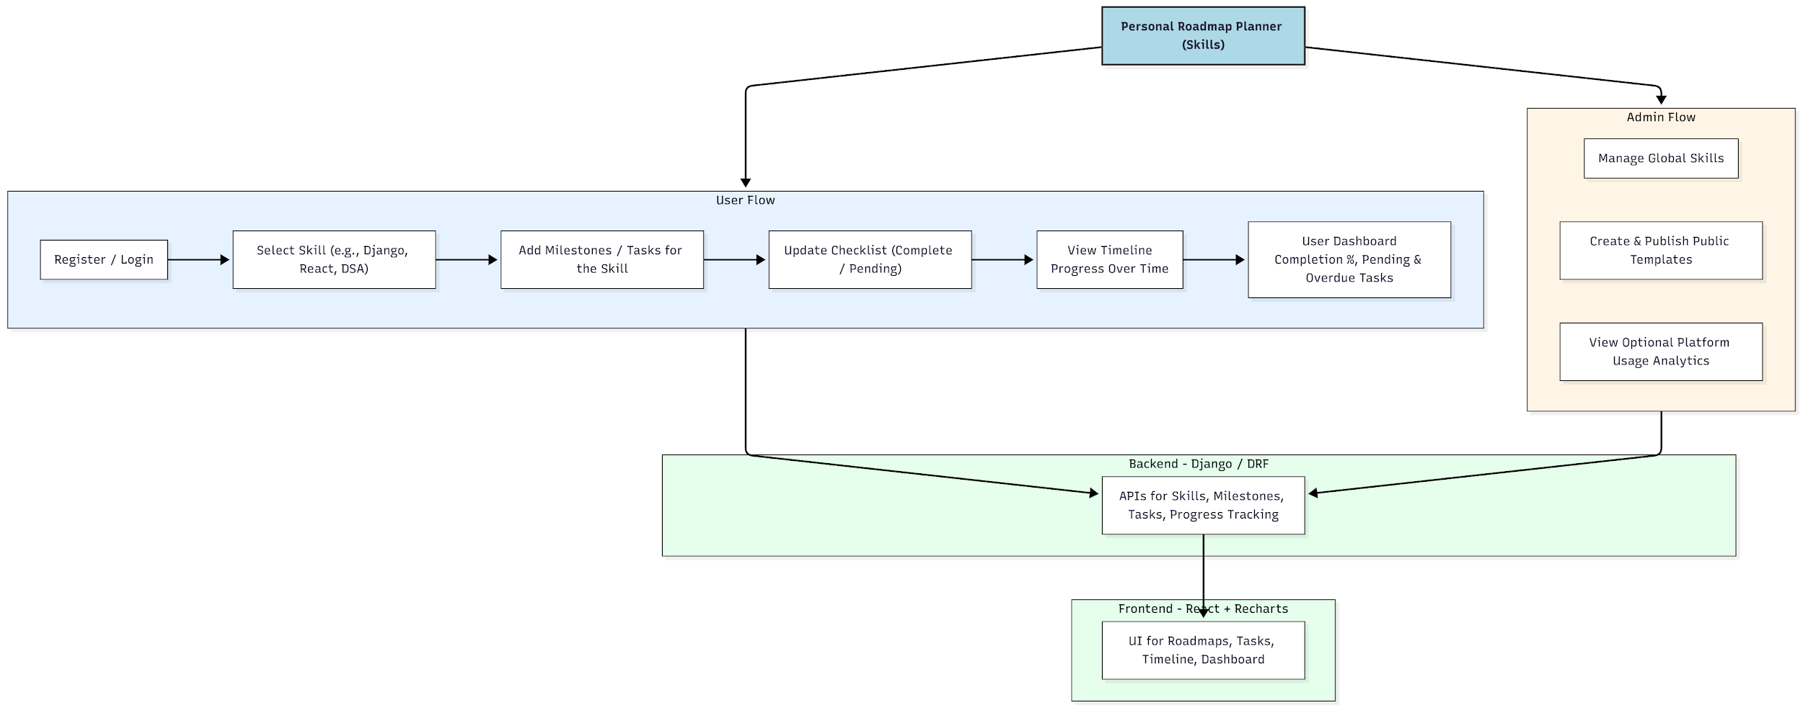

WORKING OF THE PROJECT:
Users begin by registering and selecting skills they want to learn. Each selected skill can have milestones and tasks added by the user. As tasks are completed, users update checklists, which automatically reflect in the progress dashboard.
The timeline view visualizes how the user progresses through milestones over days or weeks. The dashboard shows completion percentage, pending tasks, and overdue goals to help users stay disciplined.
Administrators create global templates, manage skill categories, and optionally analyze overall usage trends across the platform. Django REST Framework handles all backend logic, while React provides a smooth, interactive frontend experience..

SOFTWARE REQUIREMENT:
- Backend:
  - Python 3.x
  - Django
  - Django REST Framework
  - SQLite/PostgreSQL
- Frontend:
  - Node.js and npm
  - React.js
  - Axios
- Development Tools:
  - Visual Studio Code
  - Postman (for testing APIs)
  - Git/GitHub (for version control)
- Server/Deployment (Optional):
  - Gunicorn, Nginx, or Heroku/AWS for hosting

ADVANTAGES OF THE PROJECT:

• Structured skill-based learning platform
• Visual progress tracking with timeline and dashboards
• Encourages consistent and organized learning
• Easy milestone/task management
• Global templates help beginners start quickly
• Responsive and interactive interface
• Useful for students, job seekers, and self-learners
• Reduces dependency on manual planning tools

APPLICATIONS OF THE PROJECT:
• Student learning management
• Personal skill development tracking
• Career switching roadmaps
• Coaching institute skill templates
• Corporate upskilling roadmap planners
• Online learning platforms

REFERENCES:

- Django REST Framework Documentation — Django Software Foundation. Django Documentation. Available: https://docs.djangoproject.com/
- Django REST Framework. DRF Documentation. Available: https://www.django-rest-framework.org/
- React. React Official Documentation. Available: https://reactjs.org/docs/getting-started.html
- Redux. Redux Documentation. Available: https://redux.js.org/introduction/getting-started
- PostgreSQL Global Development Group. PostgreSQL Documentation. Available: https://www.postgresql.org/docs/
- MySQL. MySQL Reference Manual. Available: https://dev.mysql.com/doc/
- Git. Git Documentation. Available: https://git-scm.com/doc
- Node.js. Node.js Documentation. Available: https://nodejs.org/en/docs/
- Axios. Axios Documentation. Available: https://axios-http.com/docs/intro
- Socket.io Documentation – https://socket.io/docs/

